C++ Test 2 C++ Object oriented programming 192111380

D. Aashrit Dhanush Reddy

1.Pattren

Program:

#include<iostream>

using namespace std;

int main(){

int i,j,n=5;

for(i=0;i<=n;i++)

{

for(j=0;j<=i;j++)

{

cout<<"\*";

}

cout<<"\n";

}

return 0;

}

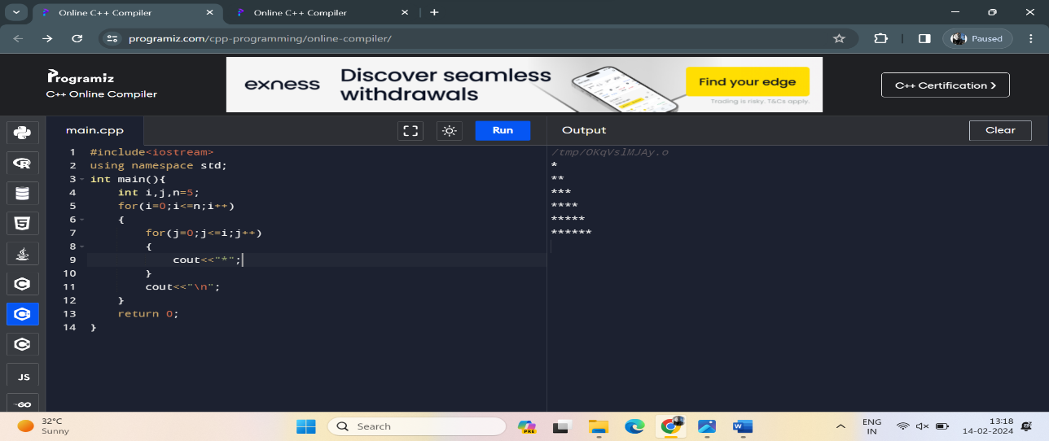Output:

2.2nd largest element in an array

Program:

#include<iostream>

#include<algorithm>

using namespace std;

int main(){

int i,j,temp,m=2;

int a[]={5,2,3,4,1};

int n=sizeof(a)/sizeof a[0];

for(i=0;i<n-1;i++)

{

for(j=0;j<n-i-1;j++)

{

if(a[j]>a[j+1])

{

temp=a[j];

a[j]=a[j+1];

a[j+1]=temp;

}

}

}

for(i=0;i<n;i++)

{

cout<<a[i]<<",";

}

cout<<"\n";

reverse(a,a+n);

for(i=0;i<n;i++)

{

cout<<a[i]<<",";

}

cout<<"\n";

cout<<"2nd largest element is:"<<a[m-1];

}

Output:

